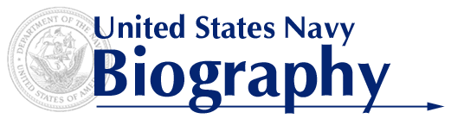

CAPTAIN LENARD C. MITCHELL
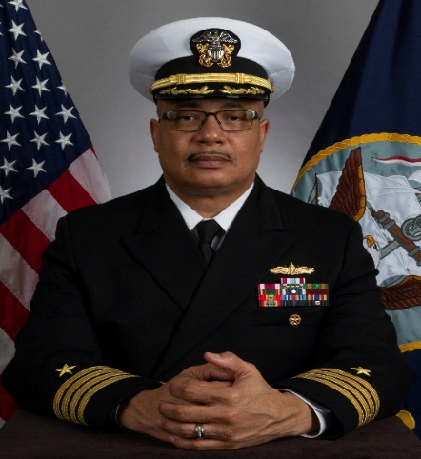
Captain Mitchell is a native of Canton, Mississippi. He enlisted in the Navy in June 1990. As an enlisted Sailor, he served as a member of the U.S. Navy Ceremonial Guard Washington, DC and as an Operations Specialist in USS BAINBRIDGE (CGN 25). He was then selected for the Broadened Opportunity for Officer Selection and Training (BOOST) program and commissioned through the Naval ROTC program. A cum laude graduate of Southern University, Baton Rouge (2000), he earned his Bachelor of Science degree in Accounting. Captain Mitchell also holds a Master of Public Administration (MPA) from Southern University (2006), and he earned his Master of Arts degree in National Security & Strategic Studies and Joint Professional Military Education (JPME) - Phase I certification from the U.S. Naval War College (2011).
Captain Mitchell’s operational assignments include an extended Division Officer tour in USS DEYO (DD 989) as the Tomahawk Strike Officer then as Combat Systems Officer. During this tour, he completed two operational deployments during which his Strike Team conducted over two dozen successful tomahawk strike engagements. Captain Mitchell served his Department Head tours as the Weapons Officer then as Combat Systems Officer in USS GETTYSBURG (CG 64). During these tours, he also completed two operational deployments in support of Operation Enduring Freedom, Baltic Operations (BALTOPS) and Counter-Piracy operations and participated in several multinational exercises. Captain Mitchell completed his tour as pre-commissioning Executive Officer, then Commanding Officer, USS LITTLE ROCK (LCS 9) BLUE.
Ashore, Captain Mitchell served as the Navigation Instructor, Junior and Senior Class Advisor and Lead Recruiter in Southern University NROTC Unit. He later served as Maritime Current Operations Officer and Executive Assistant to the Director of Operations (J3) at U.S. Southern Command. Captain Mitchell also served as the Combat Systems Director, Tactical Mentor and Integrated Air and Missile Defense Warfare Tactics Instructor (WTI) at Afloat Training Group, Mayport, FL.
Captain Mitchell assumed his current duties as Constellation Class Frigate (FFG 62) Branch Head on the staff of the Chief of Naval Operations (OPNAV N96) in July 2020.
Captain Mitchell is authorized to wear the Defense Meritorious Service Medal, Meritorious Service Medal, Navy and Marine Corps Commendation Medal (five awards) and the Navy and Marine Corps Achievement Medal (two awards) as well as multiple unit and campaign awards.

